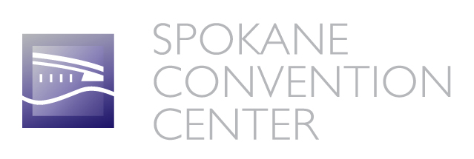

Product Sampling Agreement

To maintain the cleanliness of the facility, the Spokane Convention Center regulates the size and type of Food and Beverage dispensed at Tradeshows.

Sampling is limited to the following:
- Product sampled must pertain to the exhibitor
- Beverage portion cannot exceed two (2) ounces.
- Food portions cannot exceed ½ cubic inch in volume (i.e. bite size).
- Ready-to-Eat food may not be sold at the Spokane Convention Center
- All sampling must be confined to booth only, no walking the exhibit floor

Name of Company
Address
City, State, and Zip Code
Phone #
Facsimile #
Name of Contact

Show
Date(s) of Show | to
Product
Product Type (circle one) | Food Beverage
Portion Size

Approval:

______________________________ ____________________________________
Spokane Convention Center- Centerplate - General Manager
General Manager

